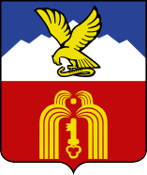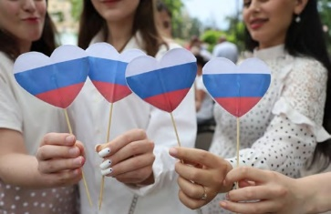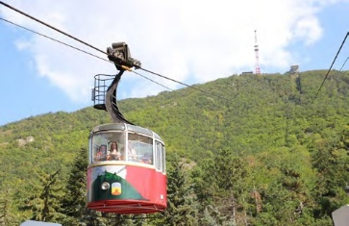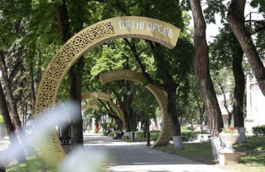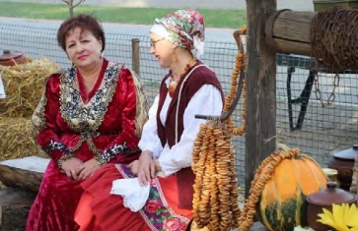CCOMBINE REHABILITATION WITH CULTURAL,EDUCATIONAL, EVENT AND OTHER TYPES OF TOURISM

- Sightseeing tours by branded electric vans in the resort area of the city

- A series of massive sports races KAVKAZ.RUN

- 6 museums, including the famous Lermontov State Museum-Reserve

- More than 10 eco-routes on the slopes of Mashuk and Beshtau mounts

- Unique theatrical excursions with costumed actors and using ofmodern technologies

- Weekly evening entertainment events both for residents and guests of the city in the parks and squares during summer time

- Availability of more than 80 collective accommodation facilities (from hostels to four-star hotels)

- Ethnographic Cossack complex "Visit the Cossacks", where you can get acquainted with the life and traditions of the Terek Cossacks, taste national cuisines, ride a horse, become a guest at a Cossack wedding ceremony

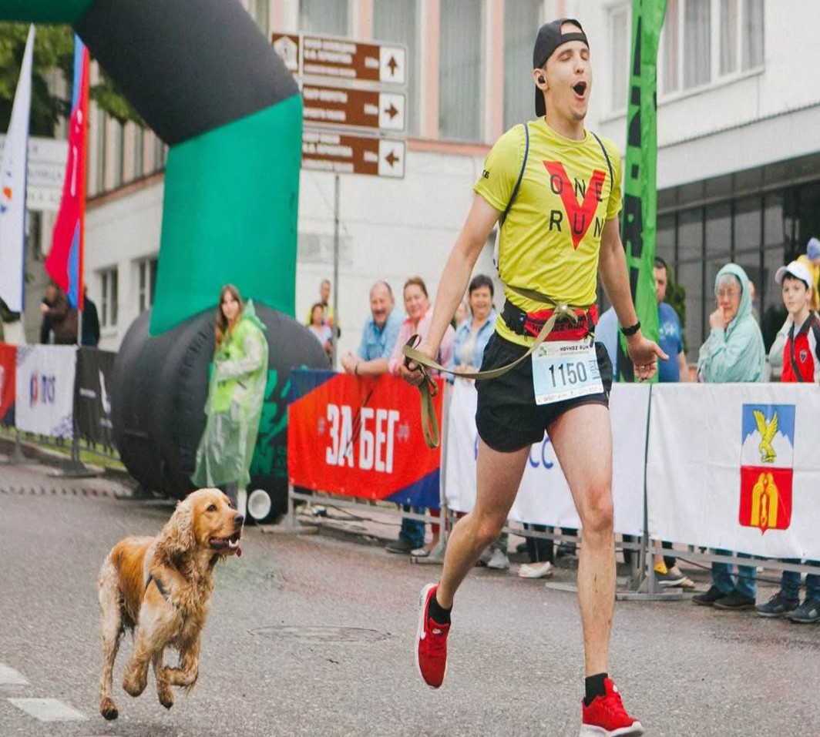

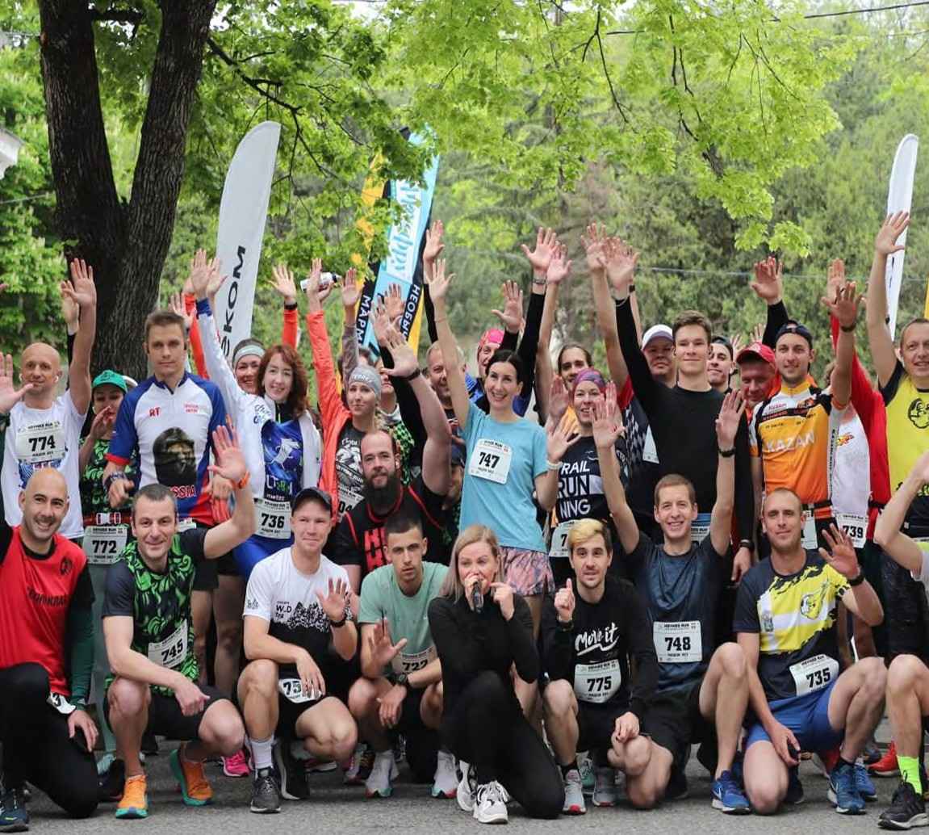

PYATIGORSK — THE CENTER OF CHILDREN, YOUTH AND FAMILY TOURISM

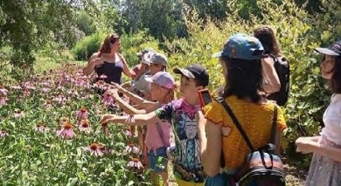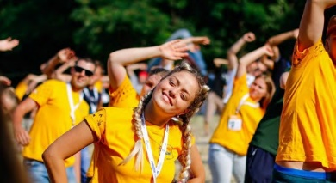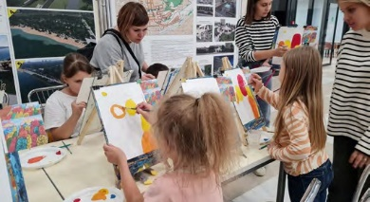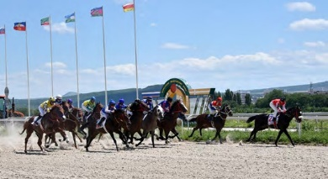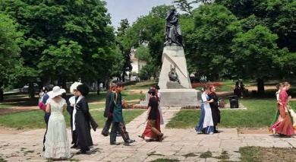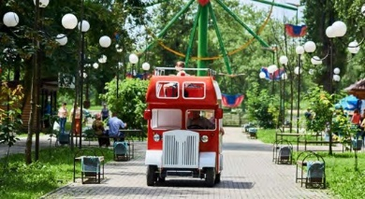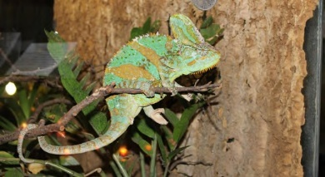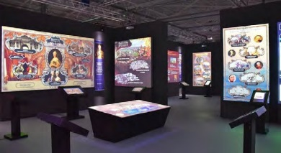

R. R. Leitzinger Center for Children's Tourism, Ecology and Creativity

Russia’s Youth Forum "Mashuk"

Over 15 creative workshops for family holidays

The only racetrack on the KMV
A unique tourist route for schoolchildren named "Lermontov's Places" is a part of the national program for the development of children's tourism

Developed infrastructure for children's entertainment (amusement park, quests, skate parks, trampoline centers, rope parks, children's playgrounds, etc.)

Tactile Museum of Insects and Exotic Animals

Interactive “Russia is my History"Museum

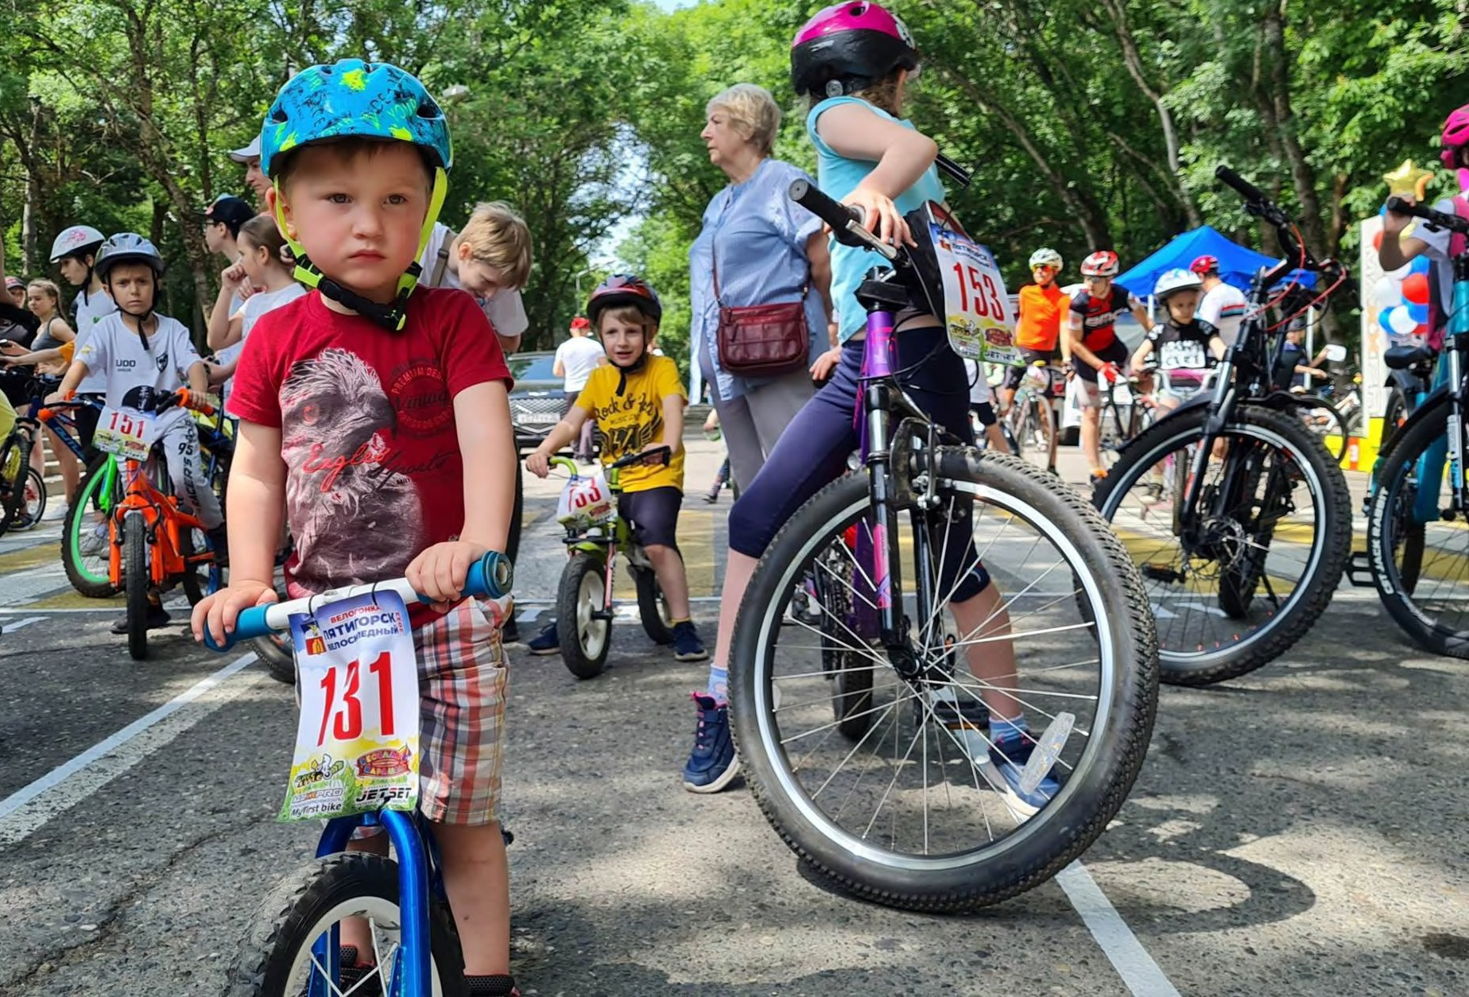

PYATIGORSK: WHERE TO GO AND WHAT TO SEE

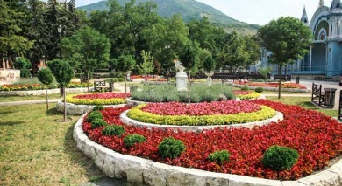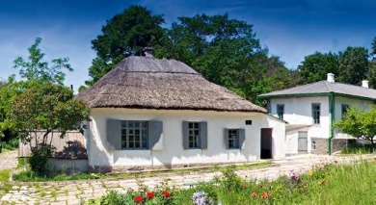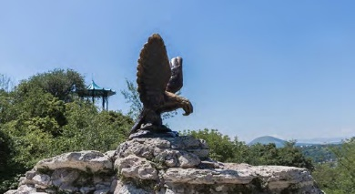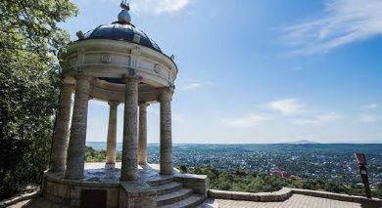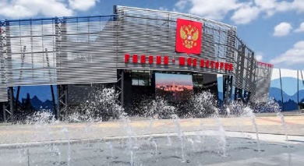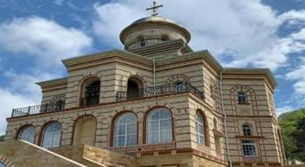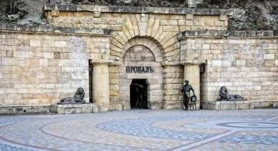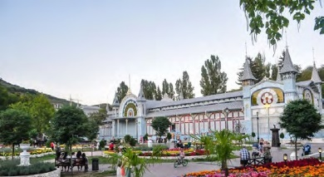
The Tzvetnik (Flower Garden) Park is the heart of the resort, the historical and cultural center of the city, a favorite walking place for residents and guests of Pyatigorsk

The State Museum-Reserve of M. Lermontov
— "the house under the reed roof" is the
only Lermontov’s place in Russia that has
been preserved in its original form

The sculpture of the Eaglefrom the legend of an eagle stung by a snake and healedby a stream of the healing water

Emmanuel’s Park is one of the oldest parks in Pyatigorsk, where you can see the sculptures of the characters of Lermontov's novel "Hero of Our Time" and the famous Aeolian Harp
The Museum and Exhibition complex "Russia — My History", where travel to the past becomes a bright and fascinating journey with the help of modern multimedia technologies

The Lermontov Gallery is aremarkable building that stands out for its unusual design

The Monastery ofAssumption of the Second Athos, located on the slope of Mount Beshtau

Lake Proval is a mysterious underground lake, to which you can walk through a long tunnel. According to the legends, a fire-breathing dragon is still living there

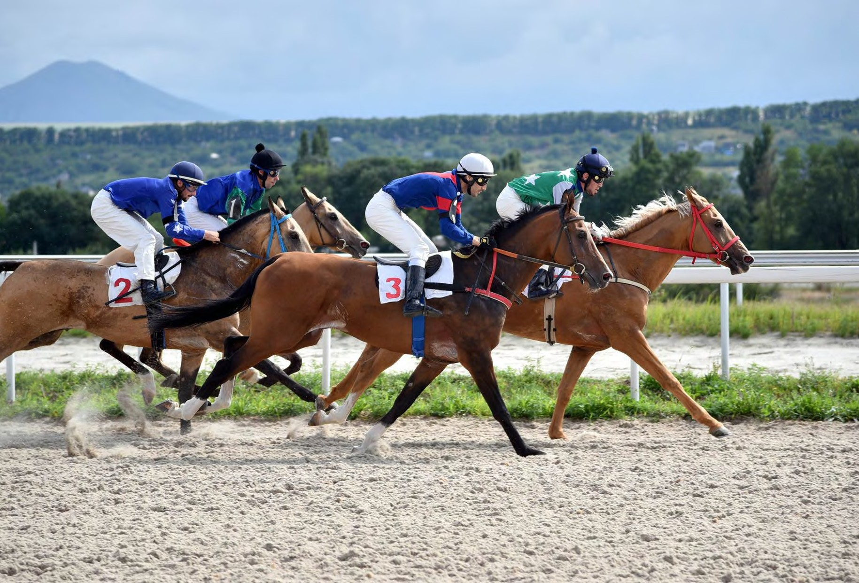

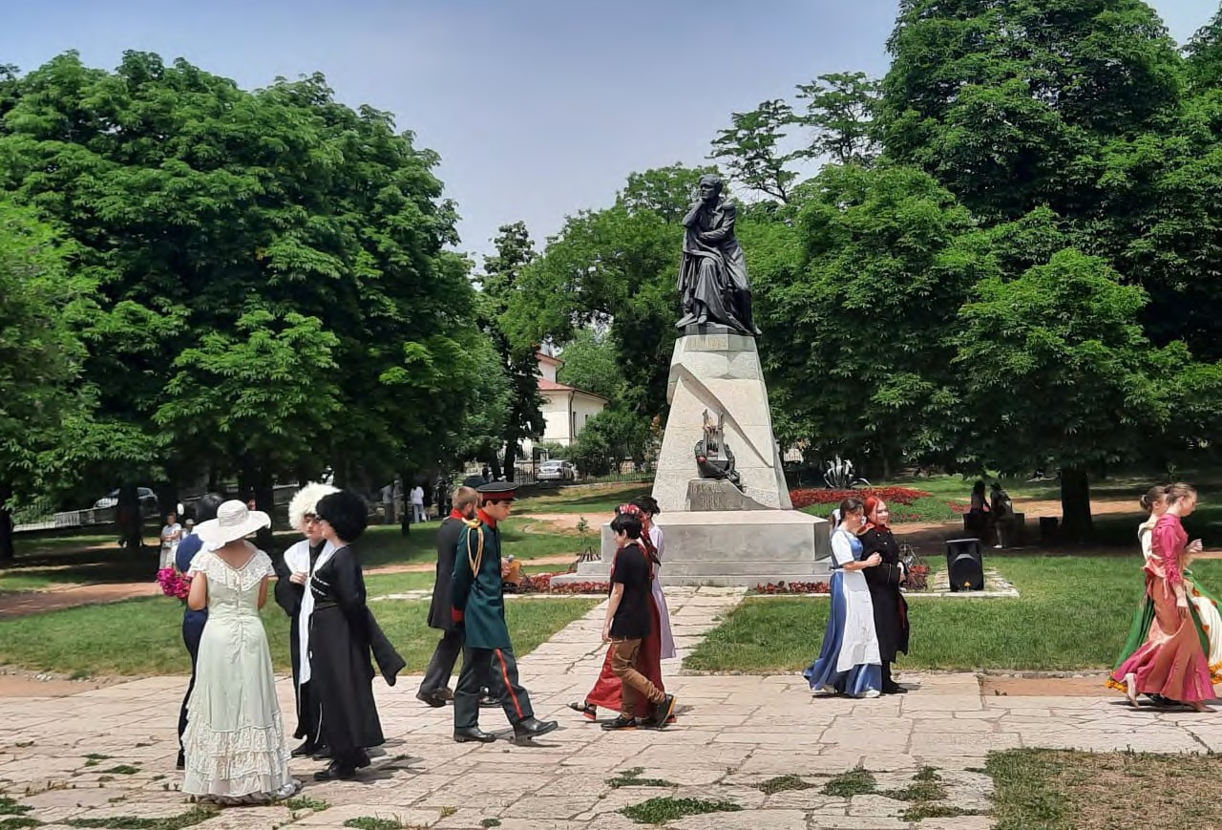

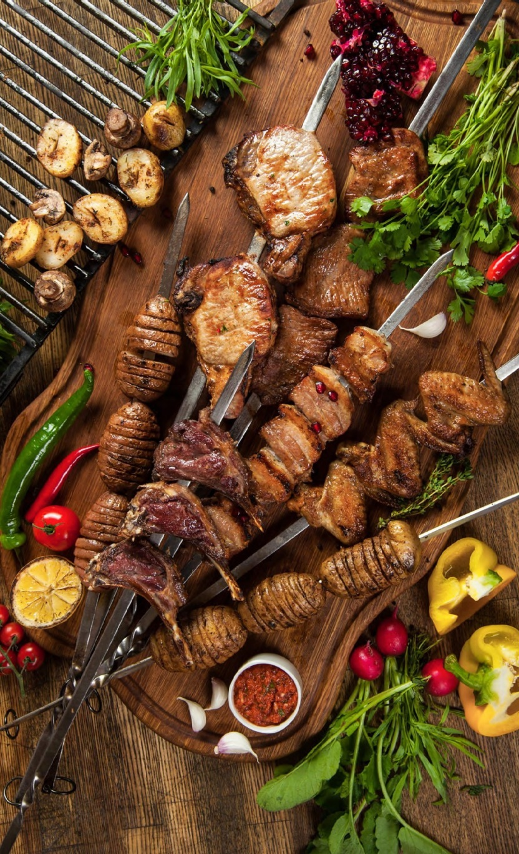CULINARY PYATIGORSK

For those who appreciate the cuisine of Caucasus with its unique aesthetics and atmosphere, we would advise to taste the local barbecue "shashlik". By the way, according to the results of a large-scale survey in social networks, Pyatigorsk is among the top three Russian cities where people do know and love to cook this dish. The best shashlik is here!

You can have a delicious meal in the cozy Italian restaurant IL CASARO, their gastronomic discovery is Italian pancerotti pies…Apropos, "IL CASARO" were the first to represent pancerotti at the KMV! Strictly speaking, this is a private cheese factory. And in addition to enjoying Italian food and drinking good wine, IL CASARO offers a range of cheese varieties and flavours made with authentic recipes.

Do you like variety, do you strive to taste life itself? Do you know a lot about specialties or do you dream of making a gastronomic journey to a far away country without leaving Pyatigorsk? Then you should definitely visit the gastromarket "Cuisines of the world"! Here, several dozens of restaurants representing cuisines of all parts of the world are concentrated on one hospitable site. Japanese, Greek, Moroccan, Mediterranean, Vietnamese, ethnic cuisines of the Caucasus — it’s not an entire list.

The Hermitage Café-confectionery is another "tasty" attraction of our city.The lightest meringue roll, the classic Napoleon cake, the mousse cakes or the exclusive Pyatigorchankacake - whatever you choose, you can be 100% sure of its superb taste..

MrSloikin Café chain is a favorite, cozy, time—tested spot for friendly gatherings and hearty snacks after long walks. The aromas of freshly brewed coffee and hot puffs straight from the oven will not leave anyone indifferent!

The gastronomic hit of Pyatigorsk is local types of plombier ice cream.Kholod, LLC is the leader in the ice cream production in our region.
Dozens of varieties, original recipes, curious novelties and good old classics are sweet refreshments for anyone’s taste.

PYATIGORSK: WHAT TO DO AND WHAT SOUVENIRS TO BRING

  - Reach the top of Mount Mashuk (on foot or by cable car), that offers stunning views of the city, the Caucasus Range and snow-white Elbrus

  - Try the healing power of hot, warm and cold narzans in the Central Drinking Gallery and pump rooms of the mineral springs

  - Visit the Cossacks in their unique ethnographic complex, an open—air museum that combines the cultural heritage of the inhabitants of the North Caucasus and the traditions of the Terek Cossacks

  - Take a ride on an electric excursion car to the famousattractions of the resort

  - Take a walk along the eco-routes of the Mount Beshtau, visiting the "Eagle Rocks", and after it enjoy the cuisine of the Caucasus in one of the authentic restaurants

  - Take mineral baths: a natural miracle in the open air — "Shameless baths" – an attraction for both guests and residents of the resort

  - Buy cosmetics made from therapeutic Tambukan mud, the healing properties of which have been known for centuries

  - Choose a souvenir made of Pyatigorsk bronze: figurines, interior decoration items, key rings, magnets, badges, etc.

  - Buy original and unique handmade ceramic and porcelain products

  - Choose gift and collectible books from Snegpublishing house that produces exclusive handmade volumes of the highest quality with colorful illustrations

  - Attend a performance at the Operetta Theatre, the only repertory musical theatre in the Stavropol region

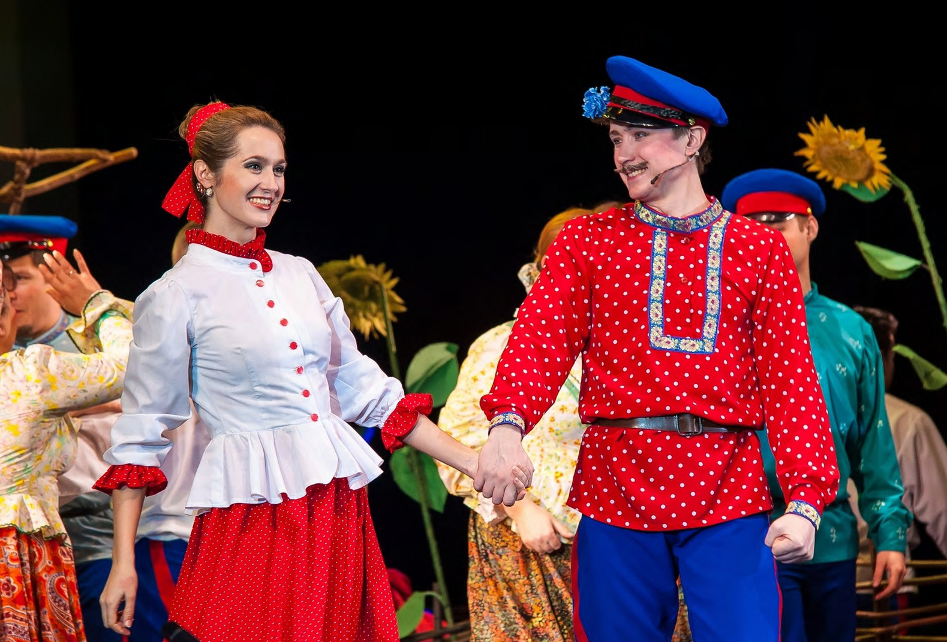

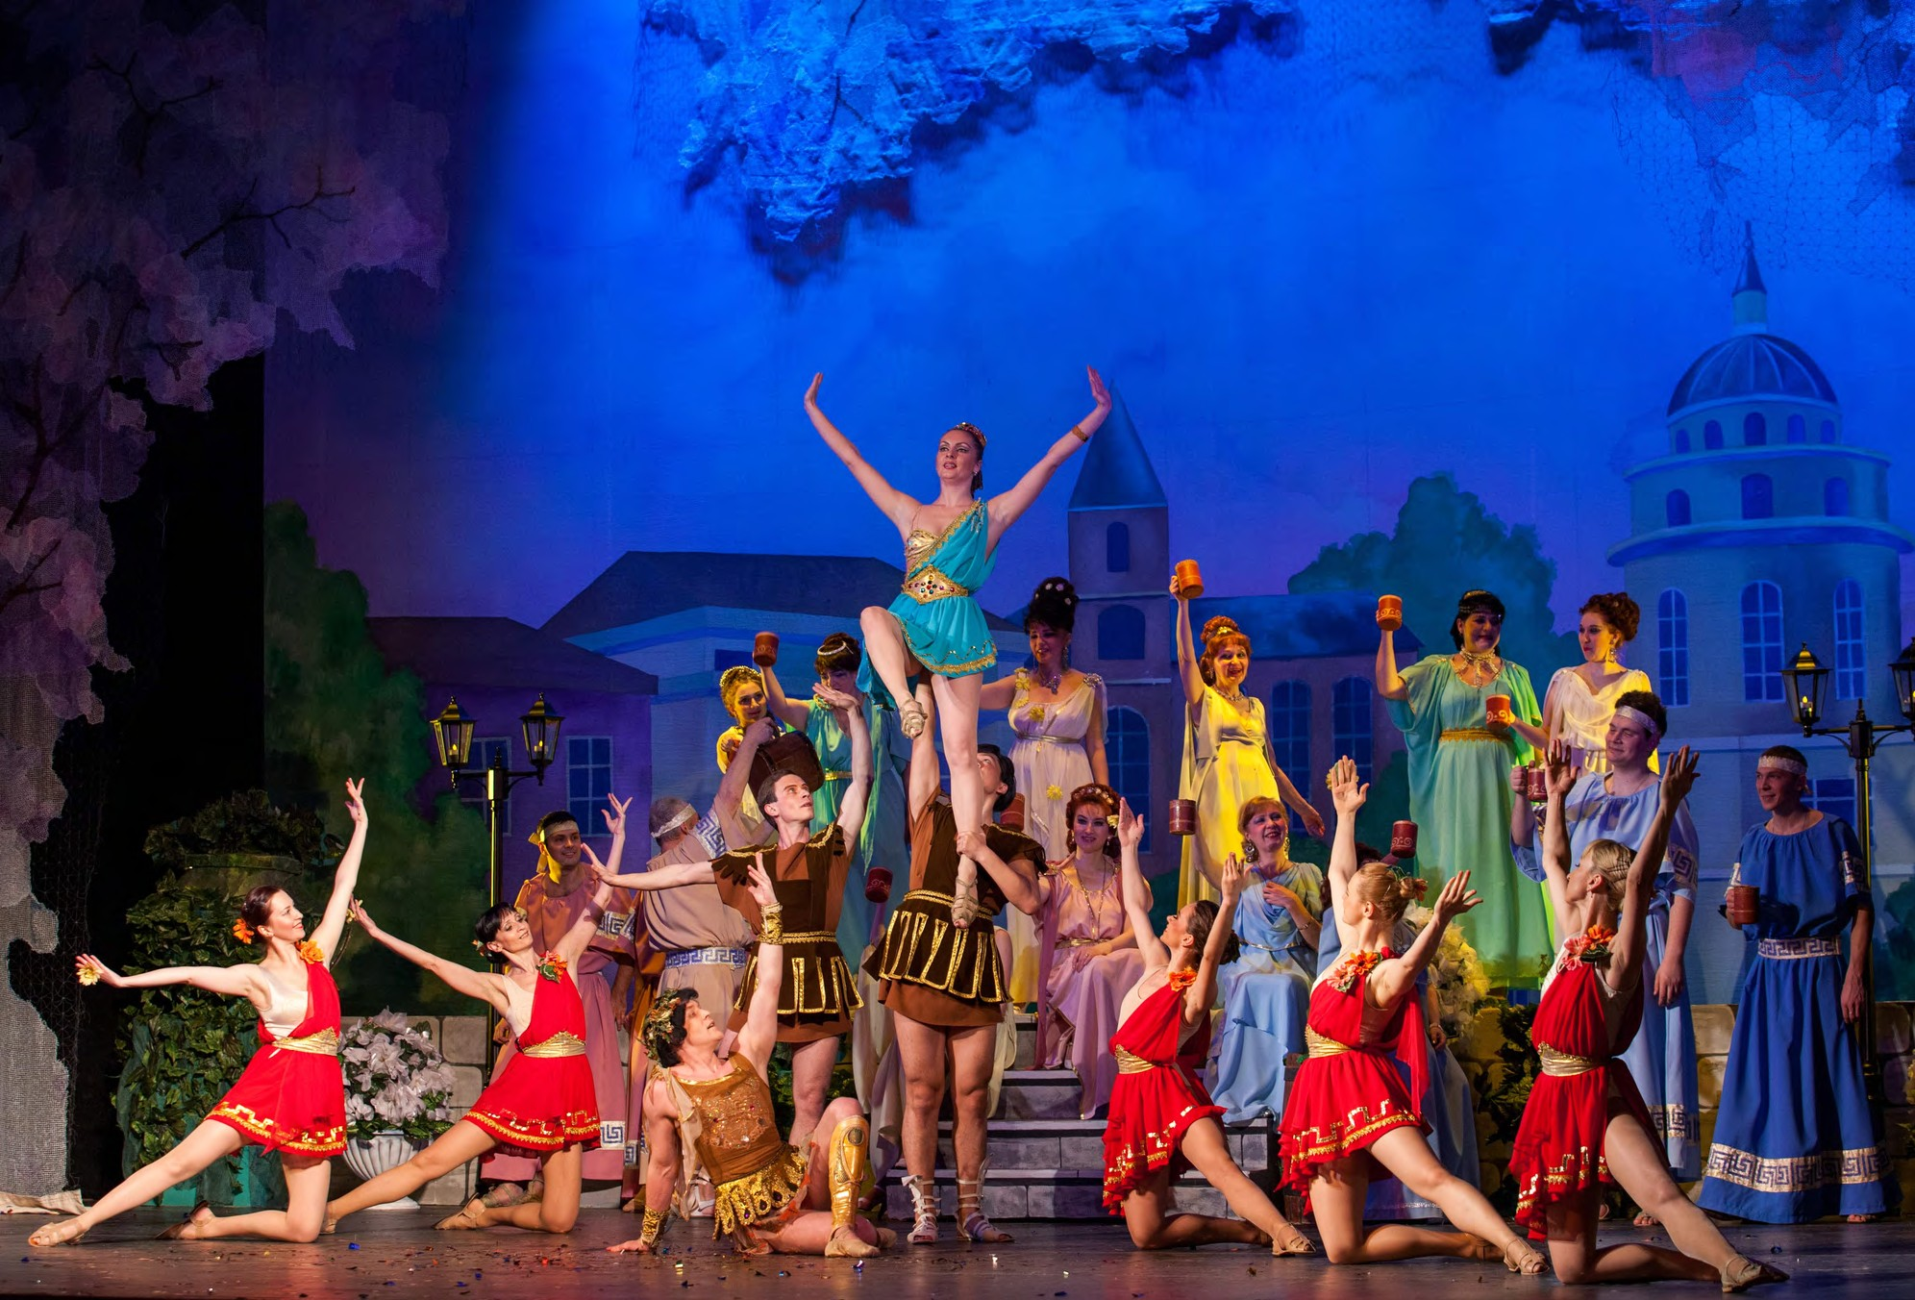

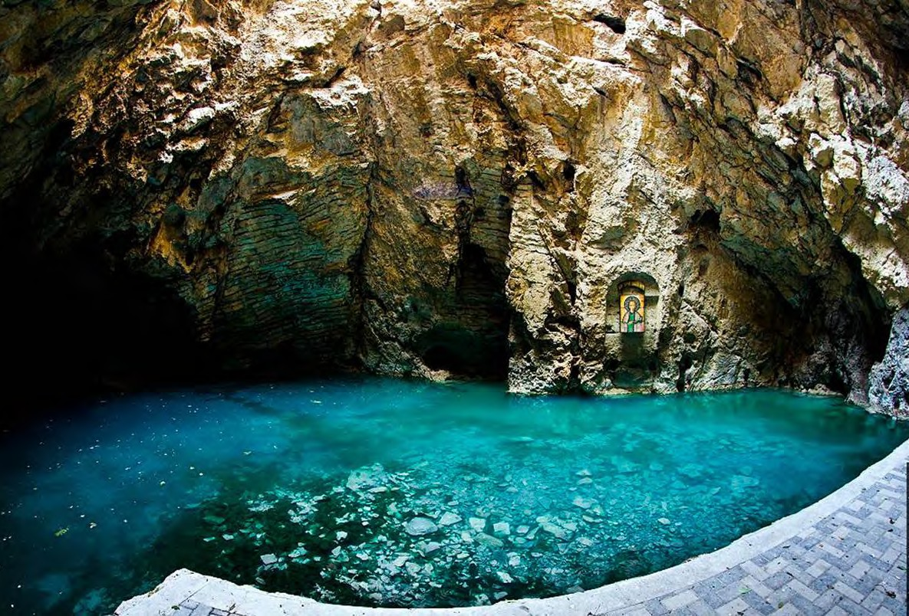

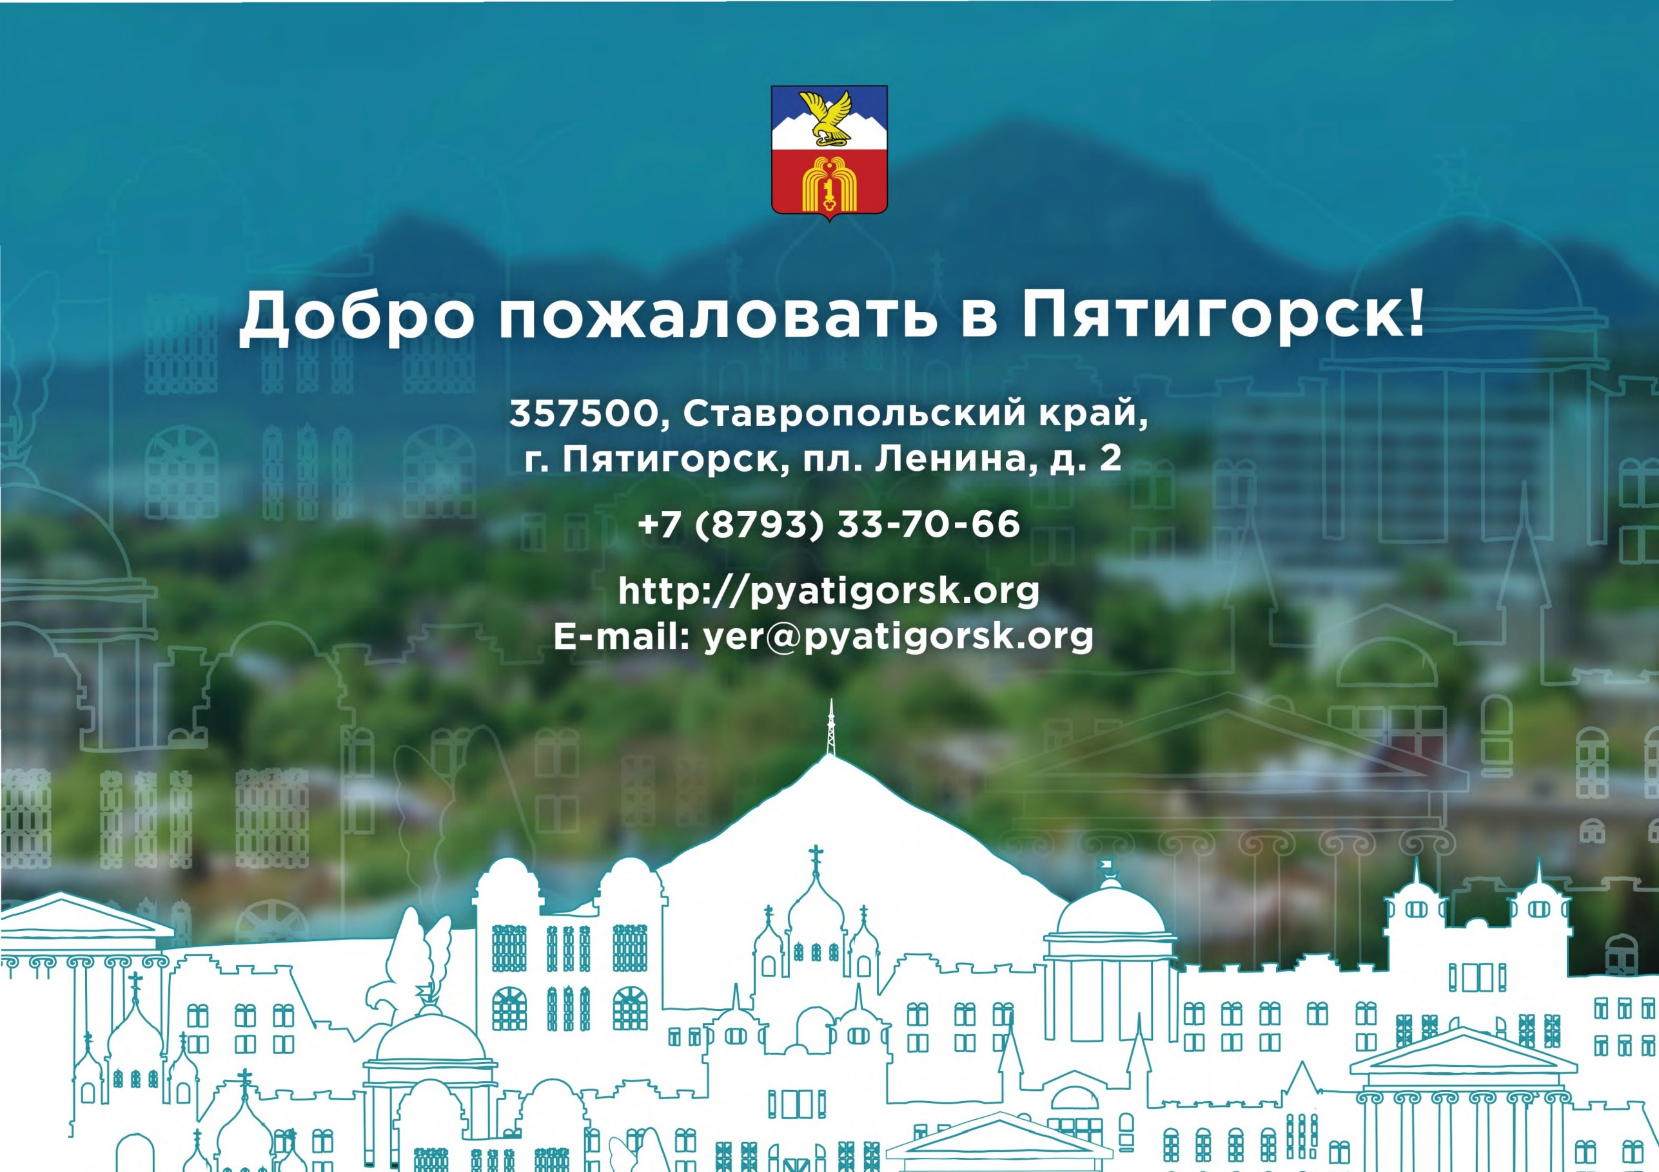

Iii Iii

